MFM2PI – Unit 5: Trigonometry – Objective #1 Date: ______________
The Pythagorean Theorem
- Calculate the side lengths of a right angle triangle using the Pythagorean Theorem

- The Pythagorean Theorem
There is a unique relationship that exists between the sides of a right angle triangle (recall that a right angle triangle has one angle that is 90°). This relationship is called the Pythagorean Theorem, and it states that the square of the hypotenuse is equal to the sum of the squares of each of the other two sides.
The Pythagorean Theorem:
c² = a² + b²

Use the Pythagorean Theorem if you are …
Given:
Need:
“c” always represents the ____________________________.
The hypotenuse is the ________________________ side of a
right angle triangle, opposite the _________ angle.
- Solving for the Hypotenuse (“c”)
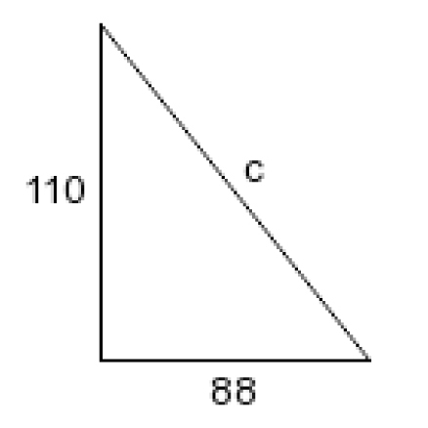
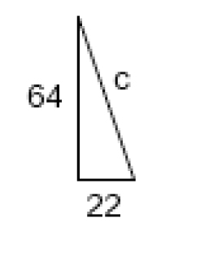
In cases where you are not given the hypotenuse, you must substitute the values of the other two legs of the triangle in for the variables “a” and “b” (it doesn’t matter which one!) into the Pythagorean Theorem.
Then, solve for the hypotenuse by gathering like terms and square rooting!
a) b)
m
r
- Solving for One of the Other Legs (“a” or “b”)
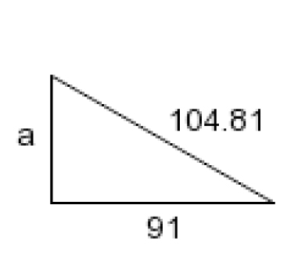
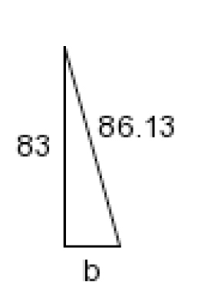
In cases where you are given the hypotenuse, you substitute the value of the hypotenuse in for the “c” variable, and the other value in for either “a” or “b” (it doesn’t matter which one!) into the Pythagorean Theorem.
Then, solve for the missing variable by rearranging the equation, gathering like terms, and square rooting!
a) b)
k
g

