MFM2PI – Unit 5: Trigonometry – Objective # 1 Self Assessment Date: ______________
Self Assessment: The Pythagorean Theorem
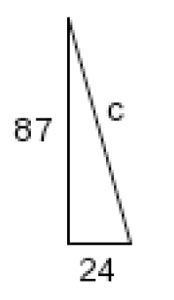
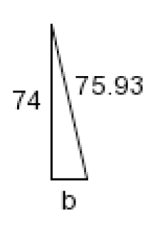
Solve the following right angle triangles for the missing side. Round your answers to one decimal place.
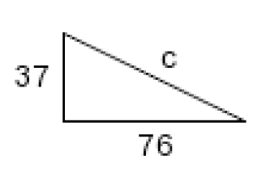
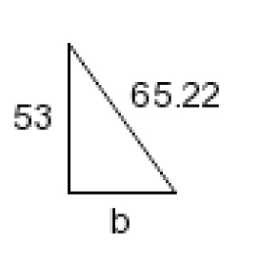
a) b)
w
z
t
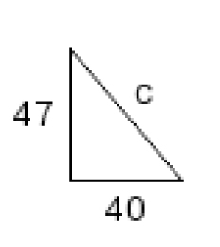
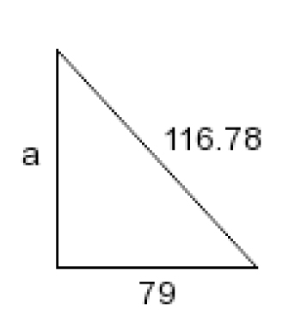
c) d)
e) f)
y
v
p

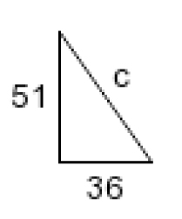
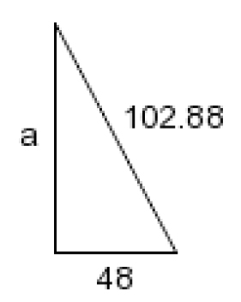
g) h)
f
t

Summarize the key learnings from this objective:
----------------------------------------------------------------------------------------------------------------------------------------------------------------------------------------------------------------------------------------------------------------------------------------------------------------------------------------------------------------------------------------------------------------------------------------------------------------------------------------------------------------------------------------------------------------------------------------------------------------------------

