MFM2PI – *Unit 1: Linear Equations – Lesson 6*  Date: ______________

**Equation Rally in Mathville!**

*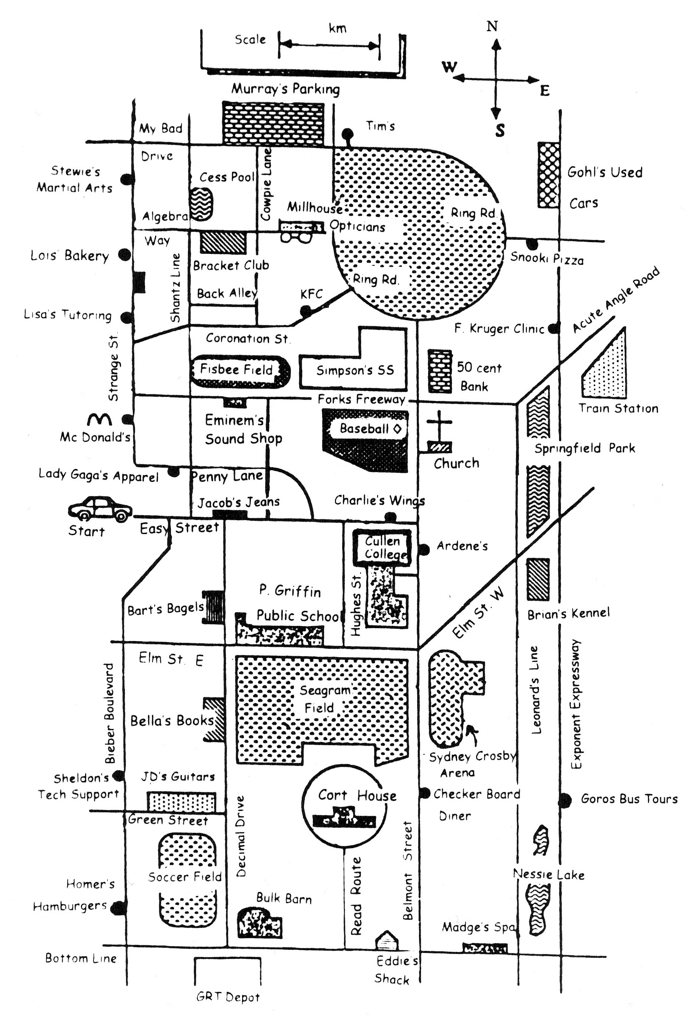This is a map of Mathville, the town where math comes to life …*

**Instructions: Using the map of Mathville, complete the following trip around town …**

1. Begin at “START” heading east on Easy Street. **Solve**: 

If x = 2, turn right at the 2nd opportunity.

If x = 10, turn left at the 1st opportunity. You are now on _____________________

If x = 5, turn right at the 1st opportunity.

2. What is the name of the 1st street you cross after the turn? ______________________

3. Stop just after this cross street. **Solve**: 

If a = 20, turn left at the 1st opportunity.

If a = 22, turn left at the 2nd opportunity.

If a = 10, turn around and turn right at the street you just crossed.

4. Drive until you get to a T-intersection. **Solve**: 

If y = 32, turn left.  
If y =2, turn right.

5. Continue to the building at the end of the street. Name it. ________________________________

6. Turn east and go to the nearest restaurant. What is the owner’s name? ____________________

7. Carry on past this restaurant and stop at the T-intersection.

Use the scale at the top of the map to determine how far you are from Ring Road. ______________

8. Drive to Ring Road and stop. **Solve**: 

If x = 3, turn left.  
If x ≠ 3, turn right.

9. Get off Ring Road at the 1st opportunity. In what direction are you traveling? _________

10. Keep driving until you get to a street named after an unappetizing pie. Turn right.

What is the street name? _______________________

11. Turn left at the “nth street”, where n is the solution to: 

12. In your rearview mirror you see people emerging from a building with something on their faces.   
   
 What is the name of the business? ______________________________

13. Keep driving to the T-intersection. Turn in the direction of the smell of fresh-baked bread and keep   
 driving until you reach a pair of arches and stop.

**Solve**:  and 

If c < w, go north and turn east at the 1st opportunity.  
If c > w, go south and turn east at the 1st opportunity.

14. Drive along this street until you see a sports field out your left window.

What sport is being played? ________________________

15. Keep driving until you reach a fork in the road (there is a park at the fork.)

Name the park ___________________________________

**Solve**: 

If x is even, take the right branch  
If x is odd, take the left branch.

16. Turn right at the next street (The name of this street might give you bad nightmares!)

What street are you on? _____________________________

17. **Solve**: 

Have your teacher check the answer!

If your answer is correct, turn north because you have been granted entrance to college.

Name the college: _______________________________

If your answer is incorrect, turn south where you have a cup of coffee and a piece of pie at a local diner and gather your strength to try this question again!

Name the diner: ________________________________

***Thanks for exploring Mathville, the town where math comes to life …***