MPM2DI – *Unit 2: Trigonometry II – Lesson 8*  Date: ______________

**The Sine Law**

1. **Proving the Sine Law**
2. For ANY triangle, the following equivalent ratios can be observed:



This relationship is called **the Sine Law**. To use the sine law, we must have one complete ratio (both values known) and one ratio with one value missing. Basically,we need***one corresponding side-angle pair*** *(e.g. $∠$ A and side a)* ***+ one other piece of information***to use the sine law.

1. Prove the ratios in the Sine Law are equivalent using the following triangles:

[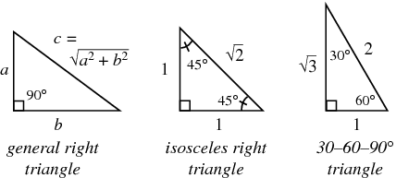](http://www.google.ca/url?sa=i&rct=j&q=&esrc=s&frm=1&source=images&cd=&cad=rja&docid=eP1i5u8bzDg4OM&tbnid=MVzeLY7Gg_vjTM:&ved=0CAUQjRw&url=http://mathworld.wolfram.com/RightTriangle.html&ei=PD5kUurFIaWx2wX5zYHoDw&bvm=bv.54934254,d.aWc&psig=AFQjCNEXualjaGisPQHhas0_QRDlfFdOlw&ust=1382387596219829)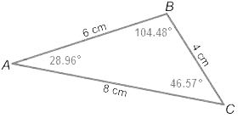

1. **Using the Sine Law Given Two Angles and One Opposite Side**

*Example 1: Given ΔELF, where* ∠*L = 58°,* ∠*F = 22°, e = 63.8 m, find side f, accurate to one decimal place.*

1. **Using the Sine Law Given Two Sides and One Opposite Angle**

*Example 2: Given ΔJER, where* ∠*J = 42°, j = 10.2 cm, e = 8.5 cm, find* ∠*E, accurate to the nearest degree.*

1. **Solving Triangles Using the Sine Law**

*Example 3: Solve ΔPEG, given ∠G = 27°, p = 17, g = 13, for all unknown values; solve sides accurate to 1 decimal place and angles to the nearest degree.*

**HW: p. 549 – 550 #1, 2, 3, 4, 5, 6, 8, 10, 11**