MPM2DI – *Unit 0: Algebraic Tools – Review* Date: _________________

**WORKSHEET: Algebraic Tools Review**

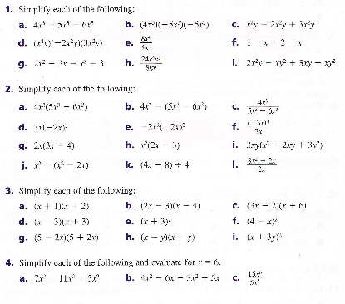

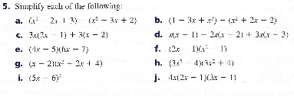

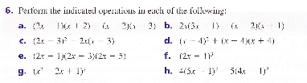

***Answers:***

 